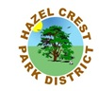

**The Senior Luncheon is back! Come out and Join the Fun!**

#227

**Indoor Barbecue! Wednesday, May 6th   
 11-1pm**

Hazel Crest Park District

2600 W. 171st Street

Hazel Crest, Illinois 60429

(708) 335-1500

BBQ Chicken

Rib Tips

Spaghetti

Fresh Green Salad

Baked Beans

**Raffles and Prizes!**

Potato Salad

Punch

Dessert (Peach Cobbler)

(Meal to be prepared by Chef John Griffis!)

**$7.00 Residents, $10.00 Non Residents**

**Registration Deadline is Wednesday, April 29, 2015**

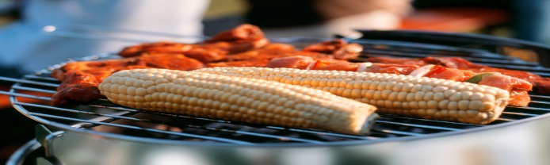

**Have a**

**Fantastic Summer!**